

International School

Capstone Project 1
CMU-SE 450

Database Design Document
Version 1.2
Date: December 12th, 2025

LeafSense - Coffee Leaf Disease Detection System

Created by C1SE.03
Pham Minh Trang - 28204632177
Nguyen Pham Nhat Huy - 28211100686
Nguyen Huu Thang - 28211102537
Duong Quoc Binh - 28219006390
Nguyen Huy Hoang Bao - 28219004148

Database Design Review Panel Representative:

Name Signature Date
Capstone Project 1 - Mentor:

Name MSc.Truong Dinh Huy Signature Date

PROJECT INFORMATION

Project acronym | LeafSense
Project Title | Coffee Leaf Disease Detection System
Start Date | September 11th, 2025 | End Date |  | December 12th, 2025
Lead Institution | International School, Duy Tan University
Project Mentor | MSc.Truong Dinh Huy  Email: huy.truongdinh@gmail.com  Tel: 0982132352
Scrum master / Project Leader & contact details | Pham Minh Trang  Email: pmtrang04@gmail.com  Tel: 0911855450
Partner Organization | Duy Tan University
Team members | Name |  | Email |  | Tel
28204632177 | Pham Minh Trang |  | pmtrang04@gmail.com |  | 0911855450
28211100686 | Nguyen Pham Nhat Huy |  | huy785619@gmail.com |  | 0395546300
28211102537 | Nguyen Huu Thang |  | nguyenhuuthang11@dtu.edu.vn |  | 0702377702
28219006390 | Duong Quoc Binh |  | duongquocbinh@dtu.edu.vn |  | 0932033856
28219004148 | Nguyen Huy Hoang Bao |  | bao91ndu1819@gmail.com |  | 0385092839

DOCUMENT APPROVALS
The following signatures are required for approval of this document.
MSc.Truong Dinh Huy  Mentor | Signature | Date
Pham Minh Trang  Student ID: 28204632177  Project Leader | Signature | Date
Nguyen Pham Nhat Huy  Student ID: 28211100686  Team Member | Signature | Date
Nguyen Huu Thang  Student ID: 28211102537  Team Member | Signature | Date
Duong Quoc Binh  Student ID: 28219006390  Team Member | Signature | Date
Nguyen Huy Hoang Bao  Student ID: 28219004148  Team Member | Signature | Date

DOCUMENT NAME

Document Title | Database Design
Author(s) | Nguyen Pham Nhat Huy, Nguyen Huy Hoang Bao
Role | Team Member
Date | December 12, 2025 | File name: | 6 C1SE.03_DatabaseDesign_Ver1.2.doc

REVISION HISTORY
Version | Date | Comments | Author | Approval
1.0 | September 11, 2025 | Create Document | Bao
1.1 | October 8, 2025 | Update Document | Huy
1.2 | December 12, 2025 | Official Document | Huy

Table of Contents
1. Introduction 1
1.1. Purpose 1
1.2. Document objectives 1
1.3. Intended audience 1
1.4. Scope, approach and methods 2
1.5. System overview 2
2. System Overview 2
2.1. Database management system configurations 2
2.2. Database software utilities 2
3. Database-Wide Design Decisions 2
3.1. Key factors influencing design. 2
3.2. Performance and availability decisions 2
4. Database Administrative Functions 3
4.1. Responsibility 3
4.2. Entity References Diagram 3
4.3. Database Identification 4
5. References 16

1. Introduction
The Database Design maps the logical data model to the target database management system with consideration of the system’s performance requirements. The Database Design converts logical or conceptual data constructs to physical data constructs (e.g., tables, ...) of the target Database Management System.

1.1. Purpose
The purpose of the Database Design is to ensure that every database transaction meets or exceeds its performance requirements. This document considers data and transaction volume to produce a schema and environment that will meet the necessary performance.

1.2. Document objectives
The Database Design Document has the following objectives:
- To describe the design of a database, that is, a collection of related data stored in one or more computerized files that can be accessed by users or developers via a DBMS.
- To serve as a basis for implementing the database and related software units. It provides the acquirer visibility into the design and provides information necessary for software development.

1.3. Intended audience
This document is intended for the following audiences:
Technical developers, who must evaluate the quality of this document.
Developer including:
- Architects, whose overall architecture design must meet the requirements specified in this document.
- Designers, whose design must meet the requirements specified in this document.
- Developers whose software must implement the requirements specified in this document.
- Quality Assurance personnel, whose test cases must validate the requirements specified in this document.

1.4. Scope, approach and methods
The LeafSense database design defines all database objects through the systematic mapping of system entities into relational tables, attributes into columns, and unique identifiers into primary or unique keys. Logical relationships between entities are implemented using foreign keys, ensuring data consistency and referential integrity.

1.5. System overview
Table 1. System overview
System Overview | Details
System Name | LeafSense – Coffee Leaf Disease Detection System
System type | Web
Operational status | In development

2. System Overview

2.1. Database management system configurations
- Database: Mysql
- System: Windows 11

2.2. Database software utilities
Table 2. Database software utilities
Vendor | Product | Version | Comments
MySQL | Workbench | 8.0.42 | Workbench is a visual tool for database architects, developers, and DBAs. It allows for data modeling, SQL development, and database management.

3. Database-Wide Design Decisions

3.1. Key factors influencing design.
The database should be designed independently while the front end and back end are still being developed.
The database should be designed to meet the data warehouse principles.

3.2. Performance and availability decisions
For enhanced efficiency, we utilize standard dimensional tables.

4. Database Administrative Functions

4.1. Responsibility
Table 3. Responsibility
Role | Name | Responsibility
Database Administrator | All Members | Implement and manage the database.

4.2. Entity References Diagram
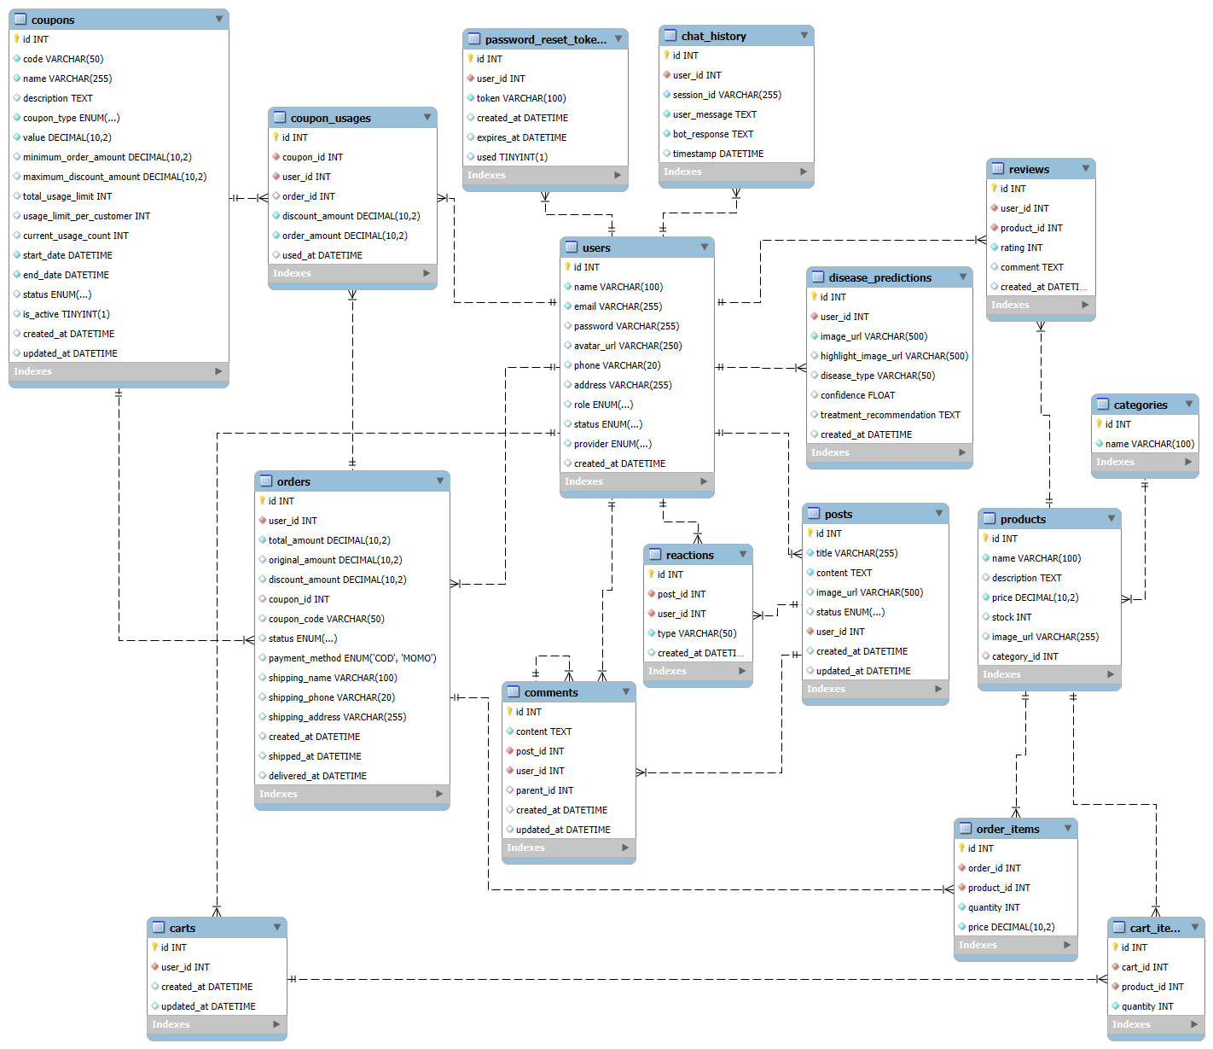
Figure 1: Entity References Diagram

4.3. Database Identification
4.3.1. users
Table 4. Users
Field | Type | Constraint | Nullable | Description
id | INT | PRIMARY KEY, AUTO_INCREMENT | No | Unique identifier for each user
name | VARCHAR(100) |  | No | Full name of the user
email | VARCHAR(255) | UNIQUE | No | Email address (used for login)
password | VARCHAR(255) |  | Yes | Encrypted user password
avatar_url | VARCHAR(255) |  | Yes | Profile image link
phone | VARCHAR(20) |  | Yes | User contact number
address | VARCHAR(255) |  | Yes | User address
role | ENUM('farmer','admin') |  | Yes | Role of user
status | ENUM('active','inactive') |  | Yes | Account status
provider | ENUM('normal','google') |  | Yes | Login method
created_at | DATETIME | DEFAULT CURRENT_TIMESTAMP | Yes | Account creation time

4.3.2. password_reset_tokens
Table 5. Password_reset_tokens
Field | Type | Constraint | Nullable | Description
id | INT | PRIMARY KEY, AUTO_INCREMENT | No | Unique token ID
user_id | INT | FOREIGN KEY → users(id) | No | Related user
token | VARCHAR(100) | UNIQUE | No | Reset token string
created_at | DATETIME |  | Yes | Token creation time
expires_at | DATETIME |  | Yes | Expiration time
used | TINYINT(1) |  | Yes | Mark if used (1 = yes)
4.3.3. disease_predictions
Table 6. disease_predictions
Field | Type | Constraint | Nullable | Description
id | INT | PRIMARY KEY, AUTO_INCREMENT | No | Prediction ID
user_id | INT | FOREIGN KEY → users(id) | No | Owner of prediction
image_url | VARCHAR(500) |  | No | Original image link
highlight_image_url | VARCHAR(500) |  | Yes | Processed/annotated image
disease_type | VARCHAR(50) |  | Yes | Disease label
confidence | FLOAT |  | Yes | Confidence score
treatment_recommendation | TEXT |  | Yes | Suggested treatment
created_at | DATETIME | DEFAULT CURRENT_TIMESTAMP | Yes | Time of prediction

4.3.4. chat_history
Table 7. chat_history
Field | Type | Constraint | Nullable | Description
id | INT | PRIMARY KEY, AUTO_INCREMENT | No | Chat record ID
user_id | INT | FOREIGN KEY → users(id) | No | Related user
session_id | VARCHAR(255) |  | No | Chat session ID
user_message | TEXT |  | No | Message from user
bot_response | TEXT |  | No | Bot’s reply
timestamp | DATETIME | DEFAULT CURRENT_TIMESTAMP | Yes | Time of message

4.3.5. categories
Table 8. categories
Field | Type | Constraint | Nullable | Description
id | INT | PRIMARY KEY, AUTO_INCREMENT | No | Category ID
name | VARCHAR(100) |  | No | Category name

4.3.6. products
Table 9. Products
Field | Type | Constraint | Nullable | Description
id | INT | PRIMARY KEY, AUTO_INCREMENT | No | Product ID
name | VARCHAR(100) |  | No | Product name
description | TEXT |  | Yes | Product description
price | DECIMAL(10,2) |  | No | Product price
stock | INT |  | Yes | Available quantity
image_url | VARCHAR(255) |  | Yes | Product image URL
category_id | INT | FOREIGN KEY → categories(id) | Yes | Related category

4.3.7. coupons
Table 10. Coupons
Field | Type | Constraint | Nullable | Description
id | INT | PRIMARY KEY, AUTO_INCREMENT | No | Coupon ID
code | VARCHAR(50) | UNIQUE | No | Coupon code
name | VARCHAR(255) |  | No | Coupon name
description | TEXT |  | Yes | Description of offer
coupon_type | ENUM('PERCENTAGE','FIXED','FREE_SHIPPING') |  | No | Type of coupon
value | DECIMAL(10,2) |  | No | Discount value
minimum_order_amount | DECIMAL(10,2) |  | Yes | Minimum order total required
maximum_discount_amount | DECIMAL(10,2) |  | Yes | Discount cap
total_usage_limit | INT |  | Yes | Total times usable
usage_limit_per_customer | INT |  | Yes | Limit per user
current_usage_count | INT |  | Yes | Current usage count
start_date | DATETIME |  | No | Start date
end_date | DATETIME |  | No | Expiration date
status | ENUM('ACTIVE','INACTIVE','EXPIRED') |  | Yes | Coupon status
is_active | TINYINT(1) |  | Yes | Active flag
created_at | DATETIME |  | Yes | Creation date
updated_at | DATETIME |  | Yes | Update date

4.3.8. coupon_usages
Table 11. Coupon_usages
Field | Type | Constraint | Nullable | Description
id | INT | PRIMARY KEY, AUTO_INCREMENT | No | Record ID
coupon_id | INT | FOREIGN KEY → coupons(id) | No | Coupon used
user_id | INT | FOREIGN KEY → users(id) | No | User who used coupon
order_id | INT | FOREIGN KEY → orders(id) | Yes | Related order
discount_amount | DECIMAL(10,2) |  | No | Discount applied
order_amount | DECIMAL(10,2) |  | No | Order total before discount
used_at | DATETIME | DEFAULT CURRENT_TIMESTAMP | Yes | Date of usage
4.3.9. orders
Table 12. Orders
Field | Type | Constraint | Nullable | Description
id | INT | PRIMARY KEY, AUTO_INCREMENT | No | Order ID
user_id | INT | FOREIGN KEY → users(id) | No | Customer placing order
total_amount | DECIMAL(10,2) |  | No | Final payable amount
original_amount | DECIMAL(10,2) |  | Yes | Amount before discount
discount_amount | DECIMAL(10,2) |  | Yes | Discount value
coupon_id | INT | FOREIGN KEY → coupons(id) | Yes | Applied coupon
coupon_code | VARCHAR(50) |  | Yes | Coupon text code
status | ENUM('PENDING','PROCESSING','SHIPPING','COMPLETED','CANCELLED') |  | Yes | Order status
payment_method | ENUM('COD','MOMO') |  | Yes | Payment type
shipping_name | VARCHAR(100) |  | Yes | Receiver name
shipping_phone | VARCHAR(20) |  | Yes | Receiver phone
shipping_address | VARCHAR(255) |  | Yes | Shipping address
created_at | DATETIME |  | Yes | Order date
shipped_at | DATETIME |  | Yes | Shipment start
delivered_at | DATETIME |  | Yes | Delivery date
4.3.10. order_items
Table 13. Order_items
Field | Type | Constraint | Nullable | Description
id | INT | PRIMARY KEY, AUTO_INCREMENT | No | Item ID
order_id | INT | FOREIGN KEY → orders(id) | No | Parent order
product_id | INT | FOREIGN KEY → products(id) | No | Product ordered
quantity | INT |  | No | Quantity ordered
price | DECIMAL(10,2) |  | No | Unit price
4.3.11. reviews
Table 14. Reviews
Field | Type | Constraint | Nullable | Description
id | INT | PRIMARY KEY, AUTO_INCREMENT | No | Review ID
user_id | INT | FOREIGN KEY → users(id) | No | Reviewer
product_id | INT | FOREIGN KEY → products(id) | No | Reviewed product
rating | INT | CHECK (1 ≤ rating ≤ 5) | No | Rating score
comment | TEXT |  | Yes | Review comment
created_at | DATETIME |  | Yes | Creation date

4.3.12. carts
Table 15. Carts
Field | Type | Constraint | Nullable | Description
id | INT | PRIMARY KEY, AUTO_INCREMENT | No | Cart ID
user_id | INT | FOREIGN KEY → users(id) | No | Owner of cart
created_at | DATETIME |  | Yes | Time created
updated_at | DATETIME |  | Yes | Time last updated
4.3.13. cart_items
Table 16. Cart_items
Field | Type | Constraint | Nullable | Description
id | INT | PRIMARY KEY, AUTO_INCREMENT | No | Cart item ID
cart_id | INT | FOREIGN KEY → carts(id) | No | Related cart
product_id | INT | FOREIGN KEY → products(id) | No | Product in cart
quantity | INT |  | No | Quantity added

4.3.14. posts
Table 17. Post
Field | Type | Constraint | Nullable | Description
id | INT | PRIMARY KEY, AUTO_INCREMENT | No | Post ID
title | VARCHAR(255) |  | No | Post title
content | TEXT |  | No | Post content
image_url | VARCHAR(500) |  | Yes | Attached image
status | ENUM('draft','pending','published','rejected','archived') |  | Yes | Post status
user_id | INT | FOREIGN KEY → users(id) | No | Author
created_at | DATETIME |  | Yes | Time created
updated_at | DATETIME |  | Yes | Time updated

4.3.15. comments
Table 18. Comments
Field | Type | Constraint | Nullable | Description
id | INT | PRIMARY KEY, AUTO_INCREMENT | No | Comment ID
content | TEXT |  | No | Comment text
post_id | INT | FOREIGN KEY → posts(id) | No | Related post
user_id | INT | FOREIGN KEY → users(id) | No | Comment author
parent_id | INT | SELF FOREIGN KEY → comments(id) | Yes | Parent comment for threading
created_at | DATETIME |  | Yes | Time created
updated_at | DATETIME |  | Yes | Time updated
4.3.16. reactions
Table 19. Reactions
Field | Type | Constraint | Nullable | Description
id | INT | PRIMARY KEY, AUTO_INCREMENT | No | Reaction ID
post_id | INT | FOREIGN KEY → posts(id) | No | Related post
user_id | INT | FOREIGN KEY → users(id) | No | User who reacted
type | VARCHAR(50) |  | No | Reaction type (like)
created_at | DATETIME |  | Yes | Reaction time

5. References
[1]. MySQL Workbench 8.0 CE
[2]. Entity Relationship Mapping

